|  |
| --- |
| *yp games.inc* |
| Greedy Bird |
| Web Game |
| Version v1.0  All work Copyright © 2015 by *YP Games*.  All rights reserved. |
| **Yun Kui Pan** |
|  |

**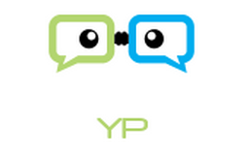**

|  |
| --- |
| Nov 08th 2015 |

Table of Contents

[I. Version History 3](#_Toc435129663)

[II. Game Overview 3](#_Toc435129664)

[III. Game Play Mechanics 3](#_Toc435129665)

[IV. Controls 3](#_Toc435129666)

[V. Detailed Game Description 3](#_Toc435129667)

[VI. Interface Sketch 3](#_Toc435129668)

[VII. Screen Descriptions 5](#_Toc435129669)

[VIII. Characters / Vehicles 5](#_Toc435129670)

[IX. Scoring 6](#_Toc435129671)

[X. Sound Index 6](#_Toc435129672)

[XI. Art / Multimedia Index 6](#_Toc435129673)

# Version History

Current Version: v1.0

Version Control is conducted by using github:

https://github.com/y-pan/greedybird

# Game Overview

Move mouse up/down to move bird up/down. Avoid dragon which can hurt bird, and catch coin for score, heart for increasing health points.

# Game Play Mechanics

Move mouse to play.

# Controls

Mouse

# Detailed Game Description

Move the bird up and down by moving mouse up and down. Bird cannot move horizontally.

Dragons, coin and heart will move from right to left randomly, and all of them will have collision effect/sound with bird.

# Interface Sketch

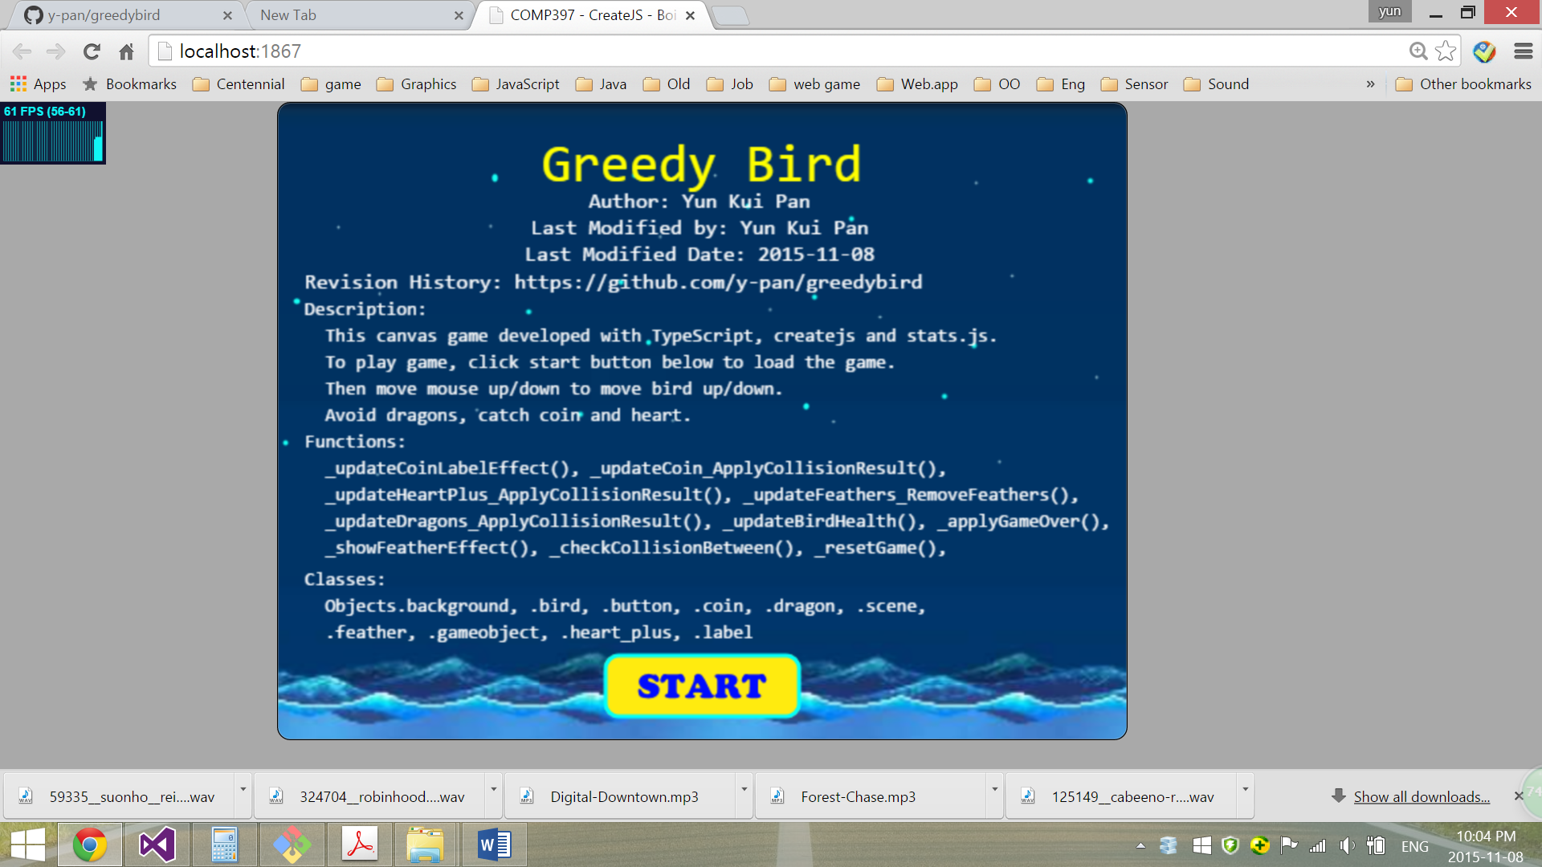

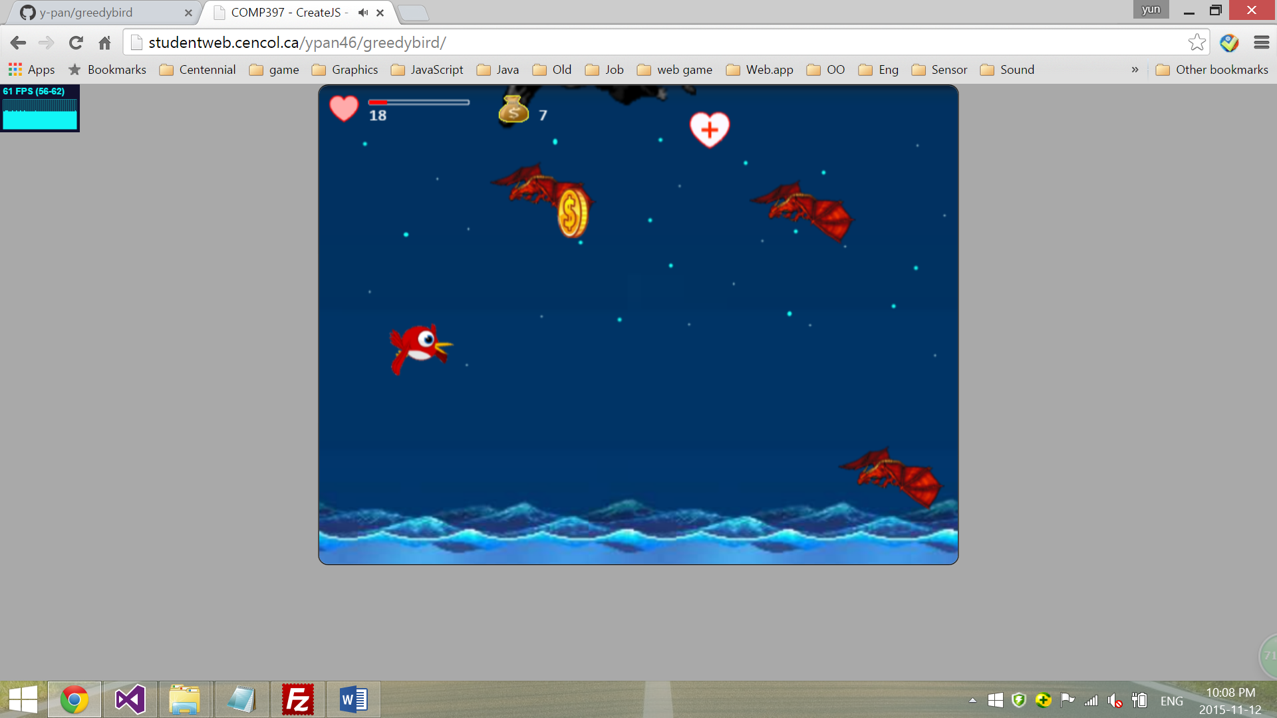

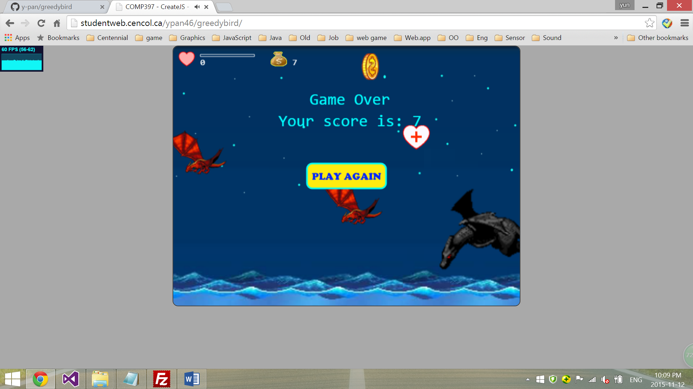

# Screen Descriptions

**Score**

**Coin for score**

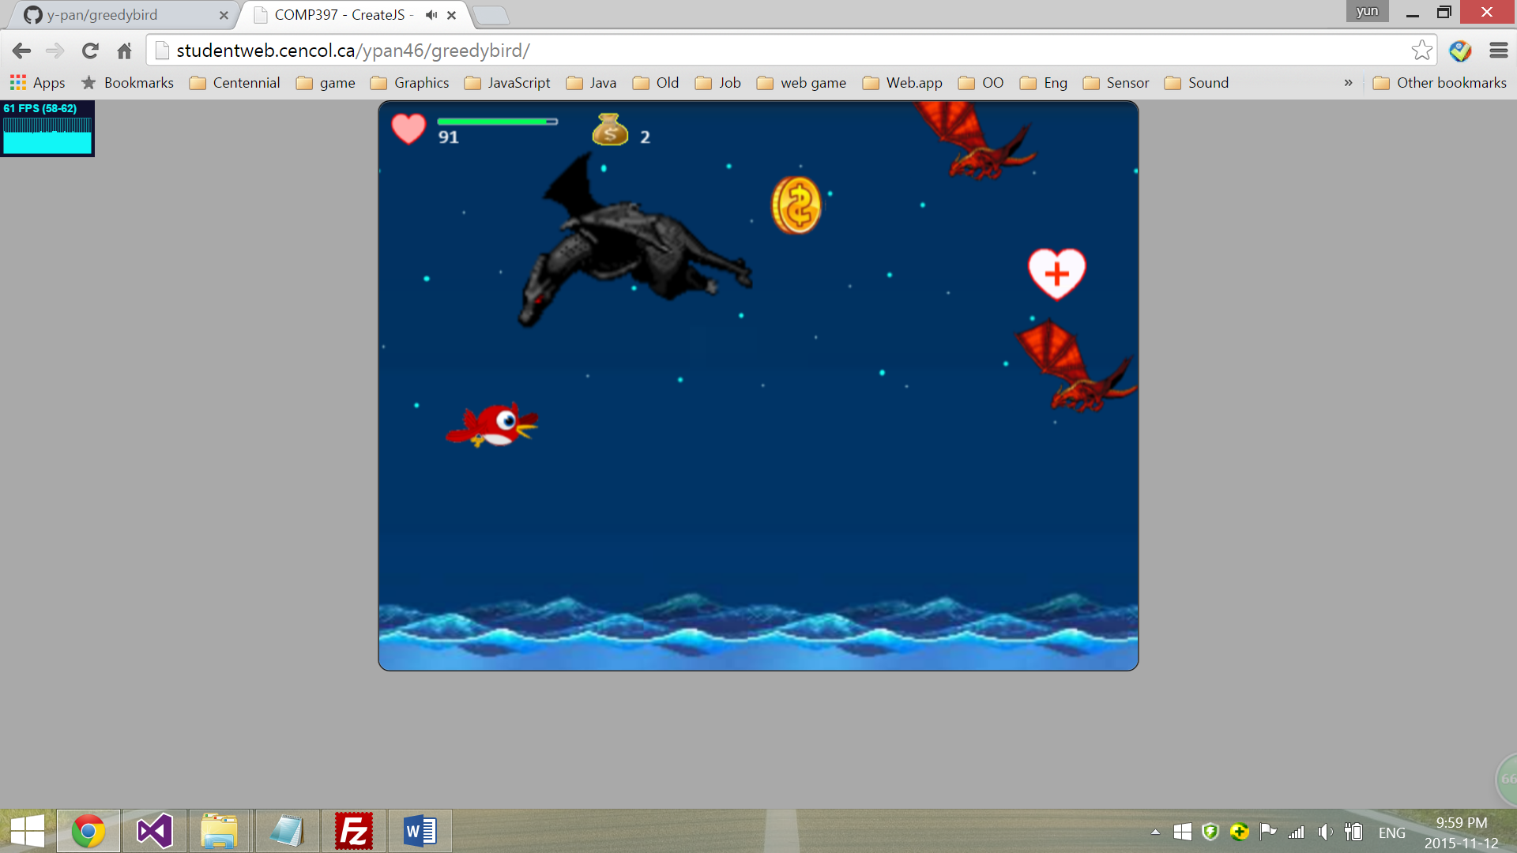

**Health**

**Heart for health points**

**Red dragon for enemy**

**Bird**

**Black dragon for enemy boss**

# Characters / Vehicles

Player controls the bird which cannot attack enemies, but has to avoid touch them. Dragons are enemies can hurt bird. The longer the dragon touches the bird, the more health points of the bird will be reduced. Black Dragon is the boss enemy.

The bird can only move up and down. Dragons will move at a randomly direction with randomly speed.

# Scoring

Catch coin to add 1 point of score.

# Sound Index

|  |  |
| --- | --- |
| **Sound clip** | **Usage** |
| 1. digital\_downtown.mp3 | Background music |
| 2. bird\_hurt.mp3 | Bird sound when gets hurt |
| 3. bird\_scream.mp3 | Bird sound when dies |
| 4. coins\_falldown.wav | Coin sound when bird gets a coin |
| 5. dragon\_roar.mp3 | Dragon sound when attacking bird |
| 6. powerUp.mp3 | Sound for bird’s catching heart |

# Art / Multimedia Index

|  |  |
| --- | --- |
| **Item Name** | **Image** |
| 1. Background | **s:\Documents\My Web Sites\GreedyBird\GreedyBird\Assets\images\background.png** |
| 2. Button | **s:\Documents\My Web Sites\GreedyBird\GreedyBird\Assets\images\playAgainButton.png**  **s:\Documents\My Web Sites\GreedyBird\GreedyBird\Assets\images\startButton.png** |
| 3. redBird | **s:\Documents\My Web Sites\GreedyBird\GreedyBird\Assets\images\redBird.png** |
| 4. redFeather | s:\Documents\My Web Sites\GreedyBird\GreedyBird\Assets\images\redFeather.png |
| 5. redDragon | **s:\Documents\My Web Sites\GreedyBird\GreedyBird\Assets\images\redDragon.png** |
| 6. blackDragon | **s:\Documents\My Web Sites\GreedyBird\GreedyBird\Assets\images\blackDragon.png** |
| 7. heart | **s:\Documents\My Web Sites\GreedyBird\GreedyBird\Assets\images\heart.png** |
| 8. moneyBag | **s:\Documents\My Web Sites\GreedyBird\GreedyBird\Assets\images\moneyBag.png** |
| 9. heart\_plus | **s:\Documents\My Web Sites\GreedyBird\GreedyBird\Assets\images\heart_plus.png** |
| 10. coin | **s:\Documents\My Web Sites\GreedyBird\GreedyBird\Assets\images\coin.png** |